Analyzing Online Sports Revenue Report
1. Instructions
Question 1:
What is the volume of products and average revenue for Adidas and Nike products based on listing price quartiles?
Question 2:
Do any differences exist between the word count of a product's description and its mean rating?

2. Data Analysis and Findings
(1) What is the volume of products and average revenue for Adidas and Nike products based on listing price quartiles?

Data preparation:
Split product description length into bins of 100-character intervals and calculate the average rating and total number of reviews.
Store the results as a pandas DataFrame called description_lengths containing columns: "description_length", "mean_rating", "total_reviews". Again, round numeric values to two decimal places.

Code Summary:
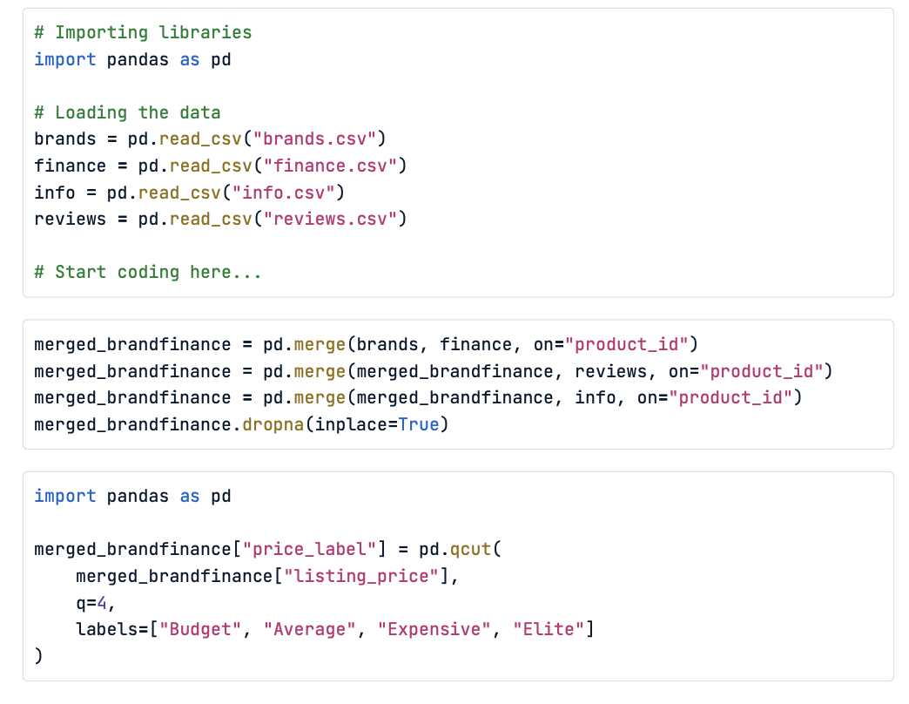
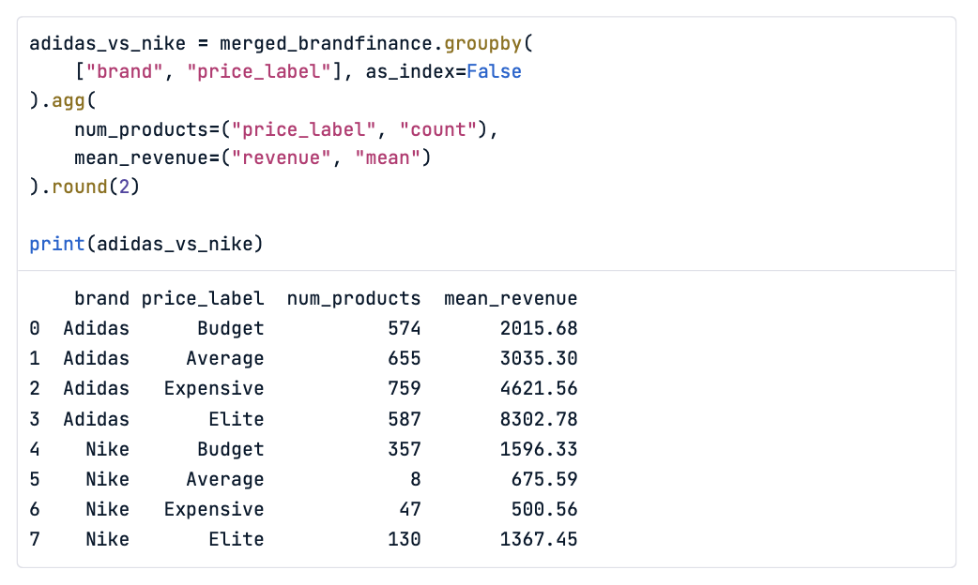
Result:
Adidas has a larger product volume across all quartiles, with 574 “Budget”, 655 “Average”, 759 “Expensive”, and 587 “Elite” products.
The average revenue increases consistently with price, from $2,015.68 in the “Budget” category to $8,302.78 in the “Elite” category.
Nike, on the other hand, offers fewer products overall — particularly in the mid-range “Average” segment, with only 8 products.
Its revenues remain relatively low across all quartiles, ranging from $500.56 to $1,596.33, and even its “Elite” products average only $1,367.45.
Finding Summary:
1.Adidas has more products and higher average revenues in every price quartile.
2.Adidas’ revenue rises steadily with price, while Nike’s revenue remains relatively flat and low regardless of quartile.

(2) Do any differences exist between the word count of a product's description and its mean rating?

Data preparation:
Split product description length into bins of 100-character intervals and calculate the average rating and total number of reviews.
Store the results as a pandas DataFrame called description_lengths containing columns: "description_length", "mean_rating", "total_reviews". Again, round numeric values to two decimal places.

Code Summary:
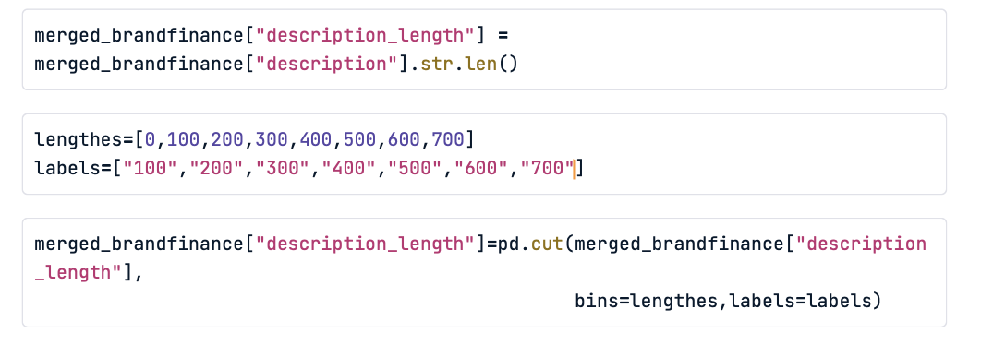
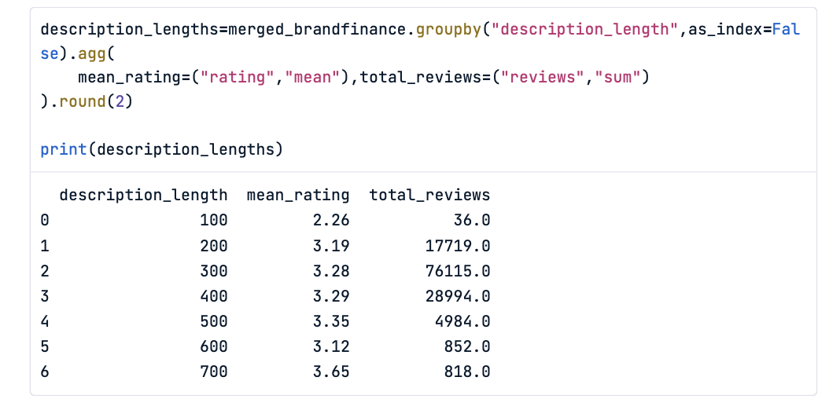
Result:
Yes, there are clear differences between description length and mean rating.
Products with very short descriptions (under 100 characters) tend to have the lowest average rating (2.26) and very few reviews (36 total).
As the description length increases from 200 to 500 characters, the mean rating rises gradually — peaking around 3.35 at 500 characters — indicating that more detailed product descriptions are generally associated with higher customer satisfaction.
However, after 500 characters, the average rating slightly fluctuates (dropping to 3.12 at 600, then rising to 3.65 at 700), likely due to smaller sample sizes in those longer-description groups

Finding Summary:
1.Short descriptions → low ratings and minimal engagement.
2.Medium-length descriptions (300–500 chars) → highest average ratings and most reviews.
3.Very long descriptions → inconsistent results, possibly due to fewer products in those bins.

3. Conclusion
In summary, product presentation matters — both in pricing and communication. Brands like Adidas benefit from clear value segmentation and stronger premium positioning, while well-crafted descriptions play a key role in enhancing perceived quality and customer satisfaction.

